Edge Intelligence Lab
P Sushma
25MML0050
Dataset Link:
https://www.gutenberg.org/cache/epub/77428/pg77428.txt
Introduction:
The code executed demonstrates several fundamental Natural Language Processing (NLP) techniques applied to a literary text. The process begins with downloading a novel from Project Gutenberg, followed by cleaning and preparing the text for analysis. Essential preprocessing steps such as tokenization, stop-word removal, and stemming are then performed to structure the data effectively.
After preprocessing, various linguistic insights are extracted, including frequency distributions of words, part-of-speech tagging, named entity recognition, and the identification of common phrases using N-grams. Together, these steps provide a comprehensive overview of the text’s linguistic patterns and overall structure.
Approach:
Resolution of Error Exceptions in NLTK
During the execution of various NLP tasks in the notebook, several Error exceptions were encountered due to missing NLTK resources. These issues were systematically identified and resolved:
1. Sentence Tokenization Error
Issue:
While performing sentence tokenization using nltk.sent_tokenize (cell ID: LXLY-NbId7J), an error occurred indicating that the resource punkt _tab was not found.
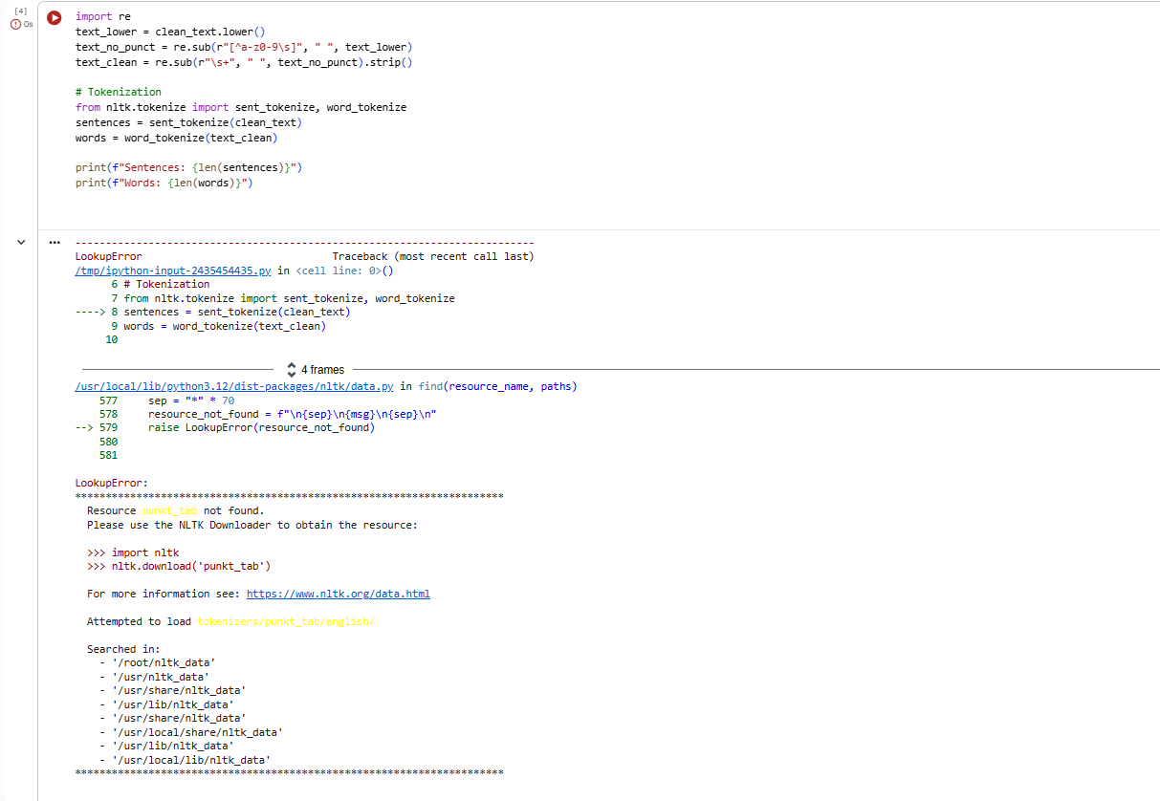
Solution:
The issue was resolved by downloading the required tokenizer model using:
nltk.download('punkt_tab')
This ensured the sentence tokeniser functioned correctly.
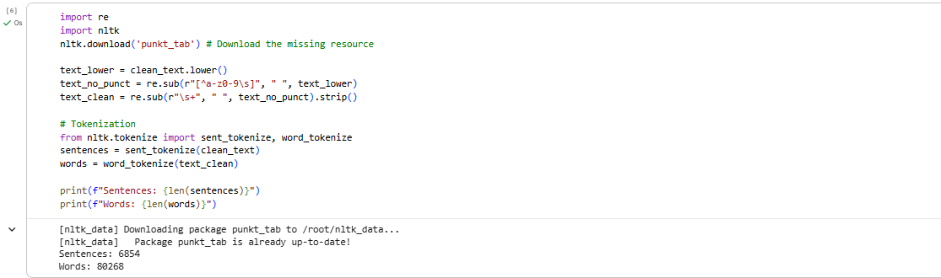
2. Part-of-Speech (POS) Tagging Error
Issue:
During POS tagging with nltk.pos_tag (cell ID: Ka1YUQdlK74U), an error was raised for the missing resource averaged_perceptron_tagger_eng.

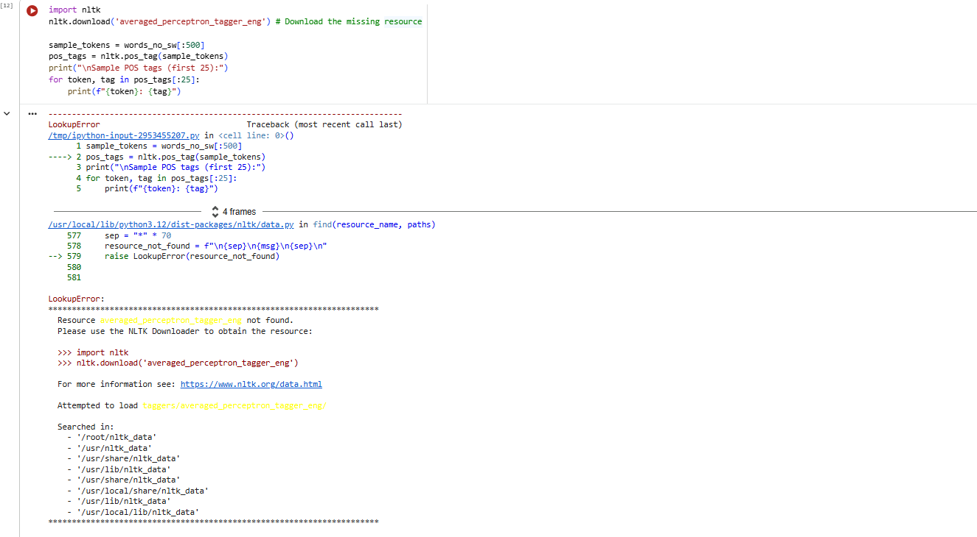
Solution:
The required POS tagger was downloaded by adding:
nltk.download('averaged_perceptron_tagger_eng')
This allowed POS tagging to execute without further errors.
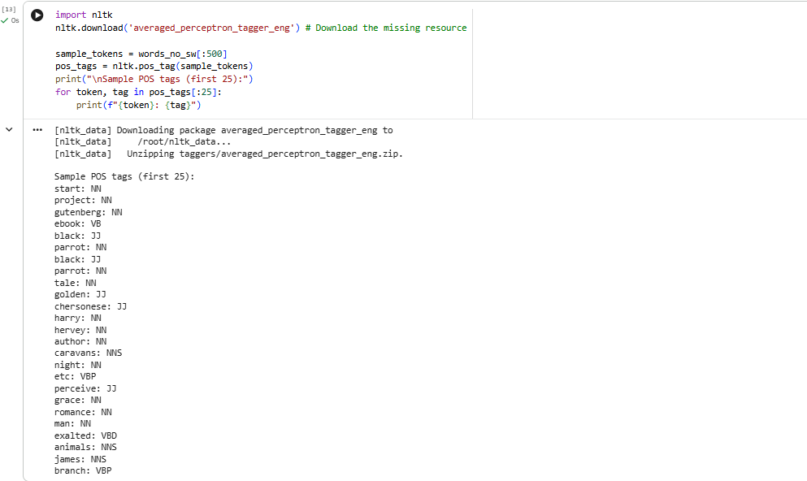

3. Named Entity Recognition (NER) Error
Issue:
While performing Named Entity Recognition using nltk.ne_chunk (cell ID: TD4MFYl_LDSf), an error was encountered due to the absence of the maxent_ne_chunker_tab resource.
Solution:
The error was resolved by downloading the necessary NER chunker using:
nltk.download('maxent_ne_chunker_tab')
This provided the required models for successful named entity recognition.
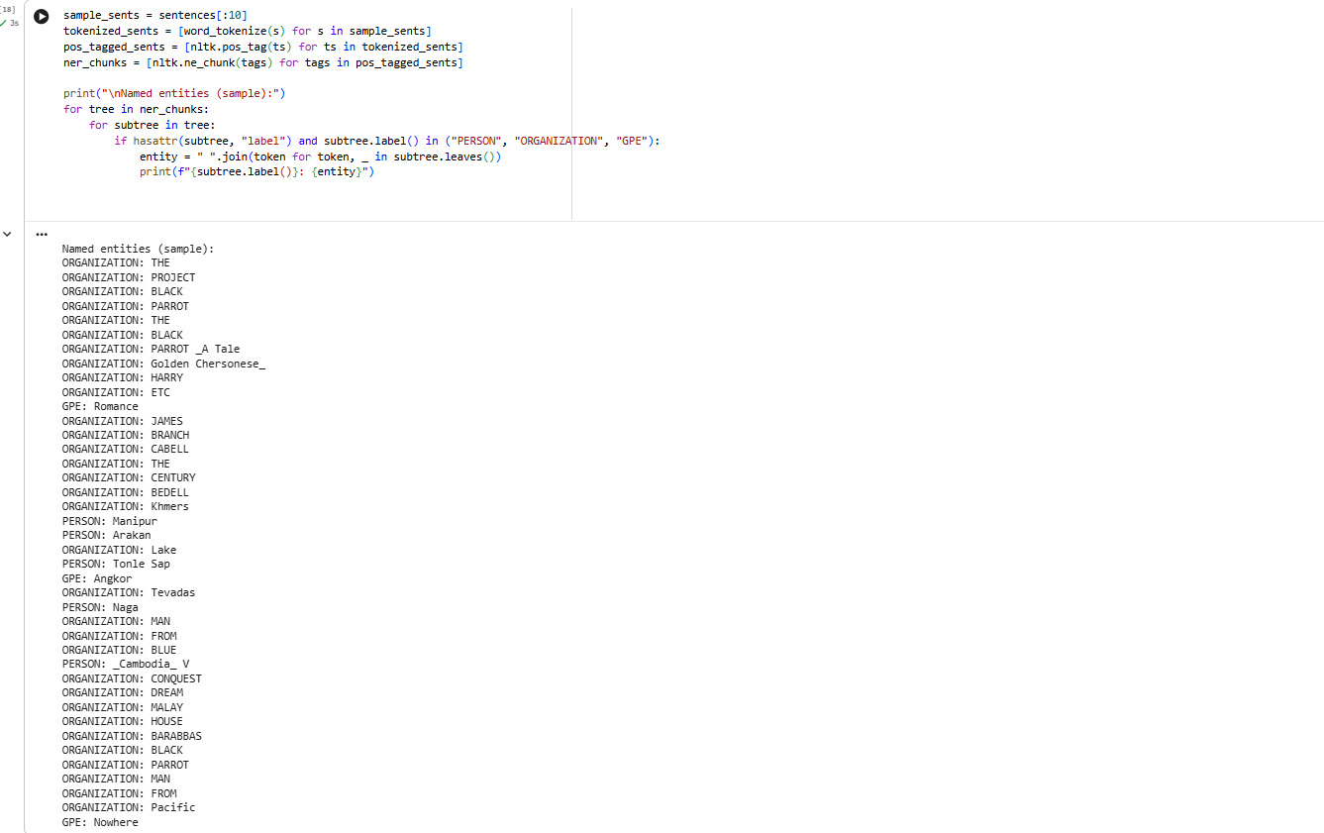

Summary:
- Collected a literary text from Project Gutenberg and cleaned it by removing unwanted sections and standardizing the formatting.
- Preprocessed the text through lowercasing, punctuation removal, and sentence/word tokenization.
- Refined the vocabulary by removing stopwords and applying stemming.
- Analysed the text using frequency distributions, POS tagging, and Named Entity Recognition to understand word usage, grammar roles, and key entities.
- Explored patterns through N-gram analysis and concordance searches to study common phrases and context.
- Resolved several NLTK Error issues by downloading the required resources, ensuring all NLP tasks ran smoothly.
Conclusion:
Overall, the notebook successfully demonstrates a complete NLP workflow applied to a literary text from data acquisition and cleaning to detailed linguistic analysis. Through systematic preprocessing and the use of various NLP techniques such as frequency analysis, POS tagging, NER, and N-grams, the text was explored from multiple linguistic perspectives. The resolution of required NLTK resource errors ensured smooth execution and reliability throughout the process. This workflow provides a strong foundation for understanding text structure, extracting meaningful information, and preparing data for more advanced NLP or machine learning tasks.

